
 National University

O f C o m p u t e r & E m e r g i n g S c i e n c- e s Chiniot - Faisalabad Campus
CL3001
Computer Networks - Lab
Lab 9 & Week-9
Objectives:
• To develop and test basic network programming concepts, including OSI model , socket APIs and TCP and UDP client server communication.

TCP Communication :TCP (Transmission Control Protocol) is a connection-oriented and reliable protocol. Before any data is sent, TCP must first establish a connection through a process called the 3-Way Handshake.
What each step means:
- SYN — The client sends a synchronization request to the server saying "I want to connect"
- SYN-ACK — The server replies saying "I received your request, I am ready"
- ACK — The client acknowledges saying "Connection confirmed, let us communicate"
- Data — After the handshake, actual messages are exchanged

UDP Communication :UDP (User Datagram Protocol) is a connectionless protocol. It does not establish any connection before sending data — it simply fires the data directly to the destination.
What this means:
- There is no SYN, no SYN-ACK, no ACK
- The client sends data immediately without waiting for any confirmation
- The server receives it and may or may not reply
- If the packet is lost — the sender does not know
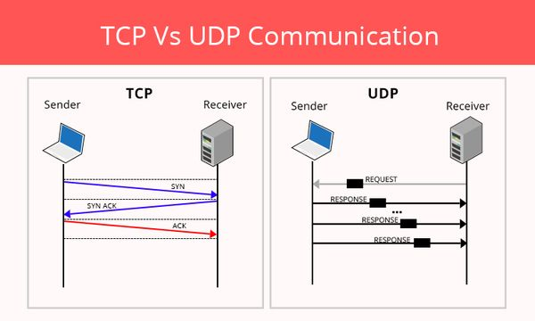

Task 1

Installation

How to Install Cisco Packet Tracer on Windows 10
To get the official version for free, you must register for a Cisco Networking Academy account.
- Sign Up: Go to Skills for All or the NetAcad website. Enroll in the free "Getting Started with Cisco Packet Tracer" course.
- Download: Once enrolled, navigate to the course resources or "Lab Downloads" section. Select the Windows 64-bit Desktop Version.
- Run Installer: Open the .exe file. Accept the license agreement, choose your installation path, and click Install.
- Authentication: Upon first launch, you will be prompted to log in using your Skills for All or NetAcad credentials to unlock all features.
Task 2

Developing Network
Packet Tracer allows you to "code" on end devices (PCs or Servers) to simulate socket behavior.
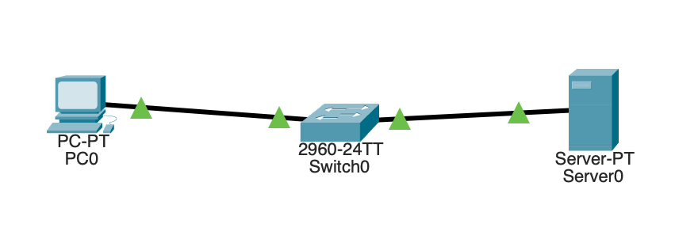

OSI Model Visualization
The best way to learn the OSI model is through Simulation Mode (bottom right icon).
• Place a PC and a Server, connect them with a Copper Straight-Through cable, and assign static IPs
(e.g., 192.168.1.1 and 192.168.1.2).
- Switch to Simulation Mode and click on the PC. Open the Web Browser and type the Server's IP.
- Click the "Capture/Forward" button. You will see an envelope (PDU).
- Click the PDU: A window opens showing the 7 Layers of the OSI Model. It will detail exactly what happens at Layer 4 (TCP segments), Layer 3 (IP packets), and Layer 2 (Ethernet frames).

Instructor: Esha Iftikhar 1 | P a g e

 National University

O f C o m p u t e r & E m e r g i n g S c i e n c- e s Chiniot - Faisalabad Campus

Socket APIs and TCP And UDP Client-Server Communication
You can write Python scripts within Packet Tracer to simulate Socket APIs:
- Setup: Select a Server device > Go to the Programming tab > Click New to create a Python file.
- Socket API Logic: Use the built-in socket library.
Note:
“ Packet Tracer uses a subset of Python (Skulpt), so some advanced libraries may be limited, but basic TCP/UDP sockets would work.” Also you can get the script generated via any LLM or GPT but Implementation is your task and inform me before using AI.

Testing for the TCP Communication
- Run the Script: Click Run on the Server's programming tab.
- Verify Port State: Go to the Server’s Desktop tab and open the Command Prompt. Type netstat to see if the port is in a LISTENING state.
- The Client: On a separate PC, you can use the Web Browser or a custom Client Script to send data to the Server’s IP on port 12000.
- Watch the Handshake: In Simulation Mode, you can watch the TCP 3-Way Handshake (SYN, SYN-ACK, ACK) occur in real-time before any data is sent.

Testing for the UDP Communication
- Run the Script: Click Run on the Server's programming tab.
- Verify Port State: Go to the Server's Desktop tab and open the Command Prompt. Type netstat to see if port 12001 is in a LISTENING state.
- The Client: On a separate PC, you can use the Web Browser or a custom Client Script to send data to the Server’s IP on port 12001.
- Watch the Handshake: In Simulation Mode observe that UDP sends data immediately — there is NO 3-Way Handshake (no SYN, SYN-ACK, ACK) before data is transmitted.
Note: Make sure that you constantly take screenshots of your progress or use a mobile or an app to record your progress so that you may not lose your work done.

Instructor: Esha Iftikhar 2 | P a g e

